S. Rushi Keshava Reddy
192472355
CSA 6503 - Generative Ai
CO4 – AT2

AIM
To develop an AI Student Support System using Python Flask and the Groq API that can answer students' academic questions, explain concepts, provide study guidance, and offer learning support through an interactive web interface.
OUTPUT / RESULT
The system was successfully developed and executed. The user can enter an academic question through the web interface, and the system sends the question to the AI model through the Groq API. The AI generates a relevant response, which is displayed on the webpage.
Example Output:
Question:
Explain the difference between BERT and GPT.
AI Response:
BERT is mainly designed for understanding text and is useful for tasks such as classification and question answering. GPT is mainly designed for generating text and is useful for chatbots and conversational applications.
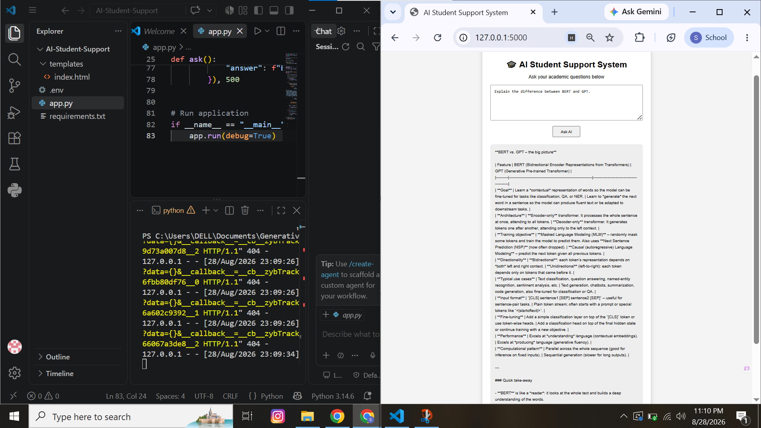
RESULT
Thus, the AI Student Support System was successfully implemented using Flask and the Groq API, providing an interactive platform for students to receive AI-based academic assistance.

